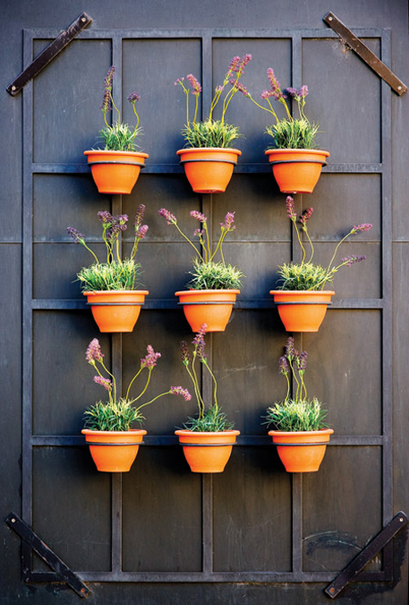

**Start new plants off right!**

* Evaluate what type of plants you have and how much water they need.
* What is the best method of watering for your soil and climate conditions?

**Healthy plants need water, but not too much.**

This may sound odd, but you can drown a plant. And in the complete opposite direction you can dehydrate a plant to death. Plants need enough water to live, but not so much as to rot out their roots or suffocate them.

Getting to the ROOT of the problem:

* Providing deep watering helps to develop a deep and sturdy root system.
* Light watering produce shallow roots.
* Always water around the root ball and not the foliage.
* Allow roots and soil to SLIGHTLY dry between waterings.

**Frequency of Water Application**

TREES, SHRUBS, PERENNIALS- every 2 days in hot weather and every 4 days in cool weather

TREES WITH GATOR BAGS- fill the bags every 2 days in hot weather and every 3-4 days in cool weather.

SOD & ANNUALS- water daily after installation for 30 days, twice a day in hot weather.

Weather and soil conditions determine how much water your plants require, common sense should prevail. If you are unsure, first check soil moisture 6” deep with a small trawl or pencil. Soil should be moist, not mud or bone dry.

Watering Instructions

TREES. SHRUBS. PERENNIALS.

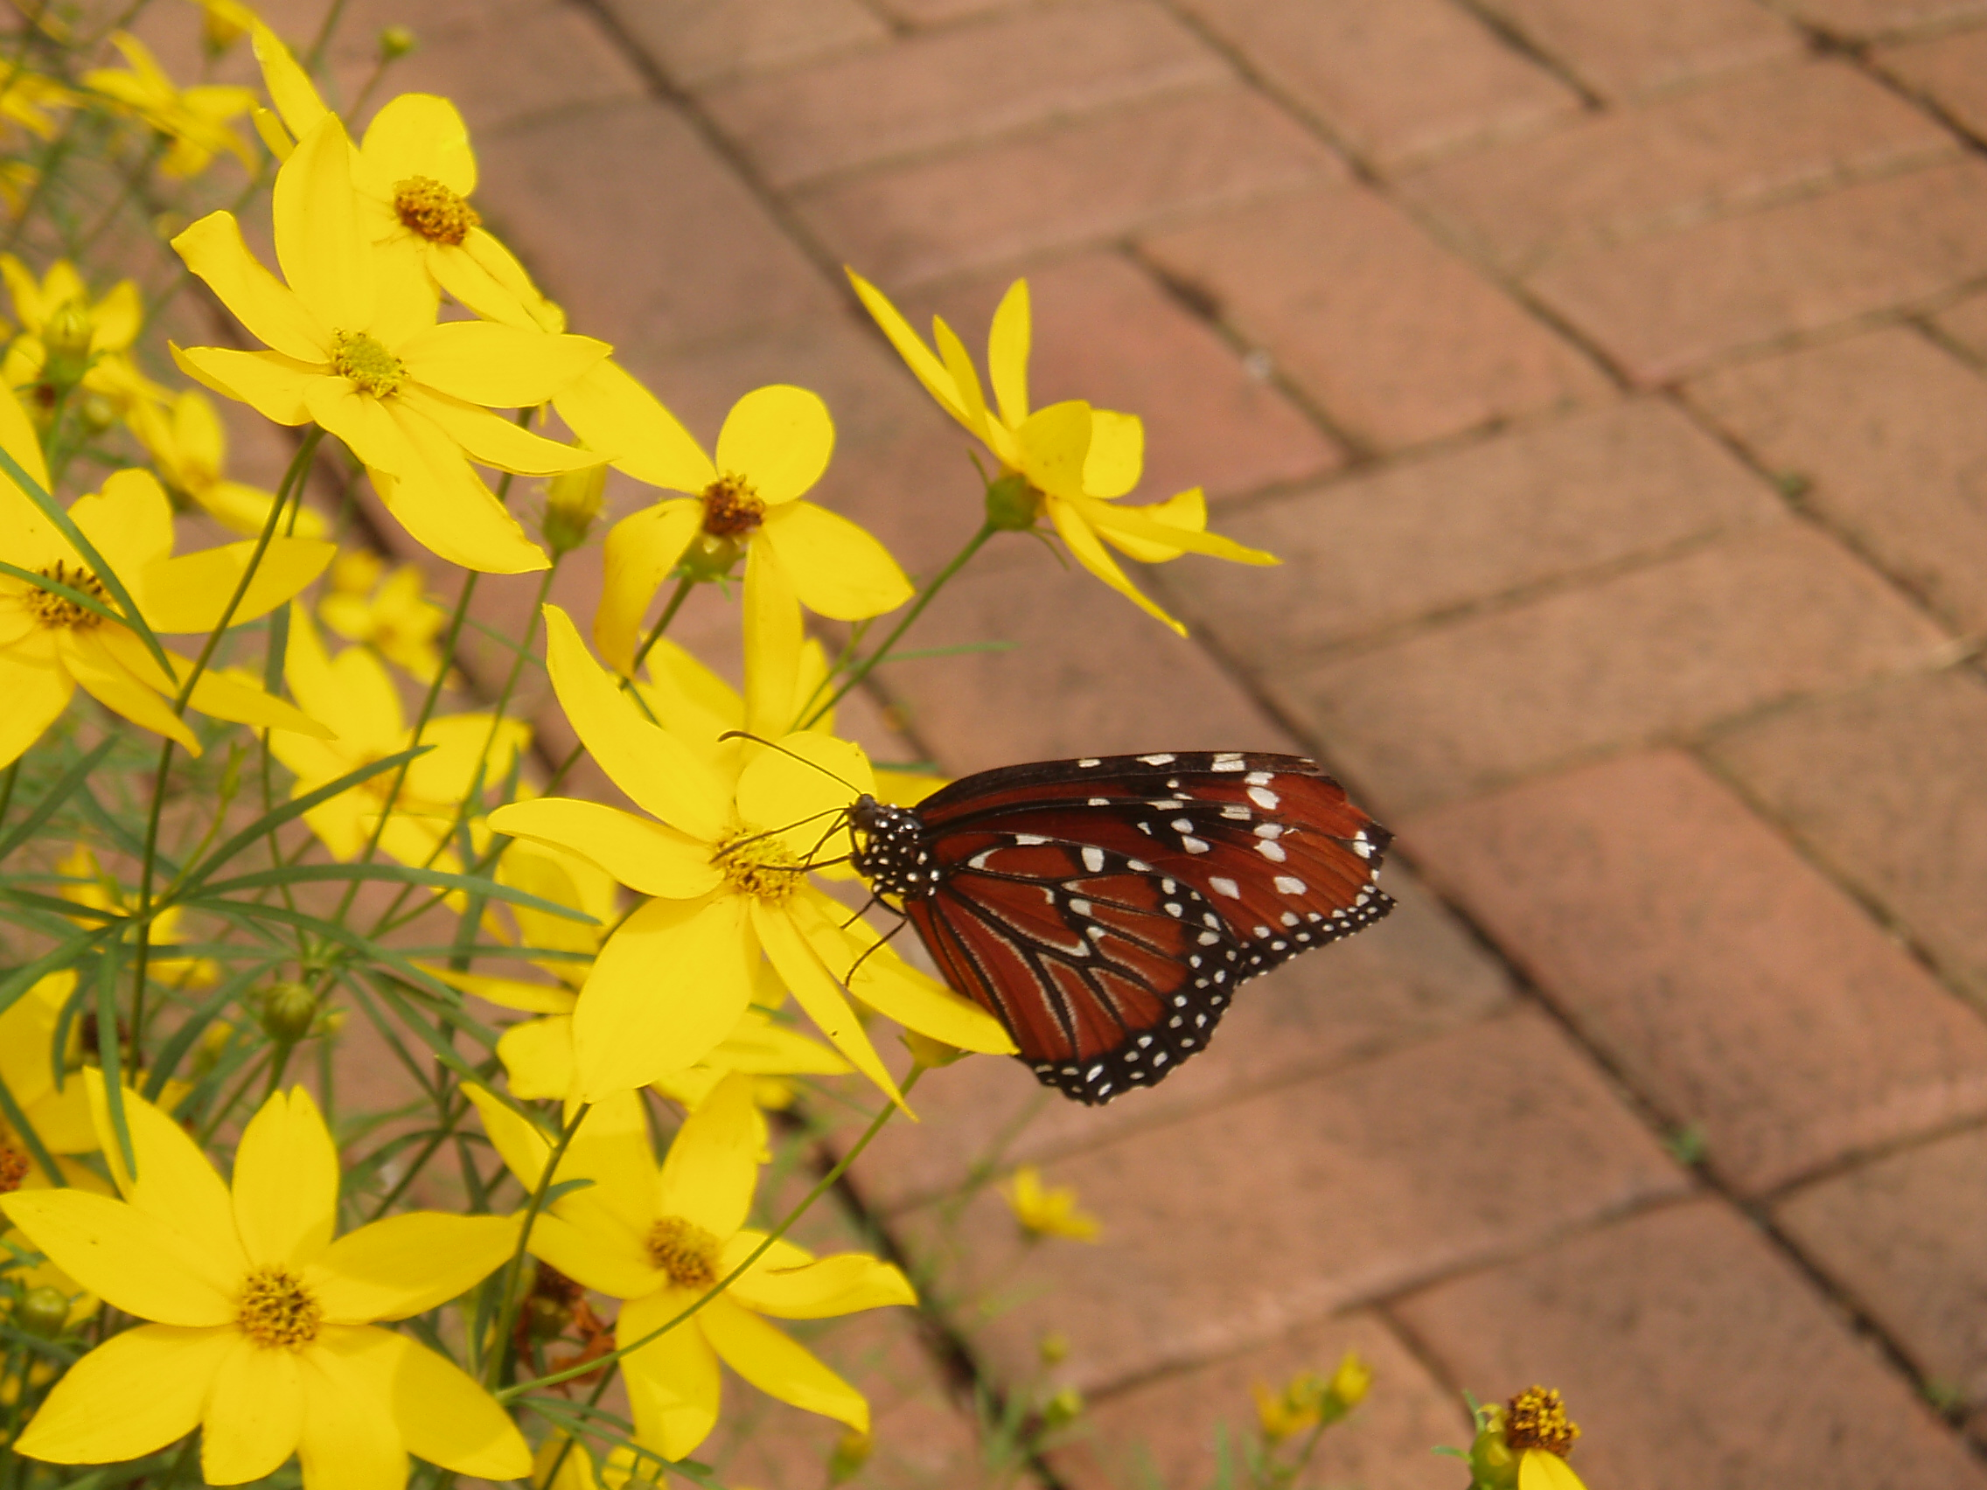

When Watering:

1. Do NOT use a sprinkler.
2. Use a hose with NO attachment.
3. Water at the BASE of the plant, never at the top.
4. Don’t put the hose TOO CLOSE to the trunk or stem of the plant — place the hose out at the root zone (under the widest branches or leaves). Otherwise, you can rot the plant.
5. Allow the hose to run at a steady stream:   
   • For Shrubs, sing ‘Happy Birthday’ SLOWLY (it’s probably best to sing to yourself)  
   • For perennials, count to ten SLOWLY (one thousand and one, one thousand and two . . . etc.)  
   • For trees, move the hose to different positions around the tree (remember, under the branches, not at the trunk!) Allow a couple of minutes per location.
6. Go down a row of plants then repeat watering until properly saturated based on soil and plant size

Gauge your performance regularly to see how well you are watering. Remove the mulch from around the plant and, using your finger or a pencil, see how deep the water is penetrating, and how wet the soil is. Your soil should be wet, but not gloppy. (Be sure to check SEVERAL locations)

Use your own judgment… If something looks very wet, don’t water it.

**Reason for deep watering**

Frequent, shallow watering (rain, sprinklers etc.) leads to shallow root systems. Plants with shallow root systems are not very drought-tolerant.

**Watering times based on plant sizes**

**Container plants**

(most perennial and shrubs)

1-3 gal pot: 10 minutes  
5-10 gal pot: 20 minutes  
15 gal or larger pot: 30 minutes

**Balled and Burlaped plants**

(some large shrubs and most trees)

1.75" - 2.5" caliper: 45-60 minutes  
3" or larger caliper: 60-80 minutes

**Conditions Requiring More Frequent Watering**

* Windy locations - wind dries plants out more quickly
* Slopes - plants planted on a slope will dry out more quickly, since the water runs downhill away from the roots. Be sure to keep the hose pressure at a very slow trickle, place it above the plant on the slope and water more frequently.
* Overhangs - plants placed under a roof overhang will need more water, since the soil in that area tends to be drier as it does not receive any rain

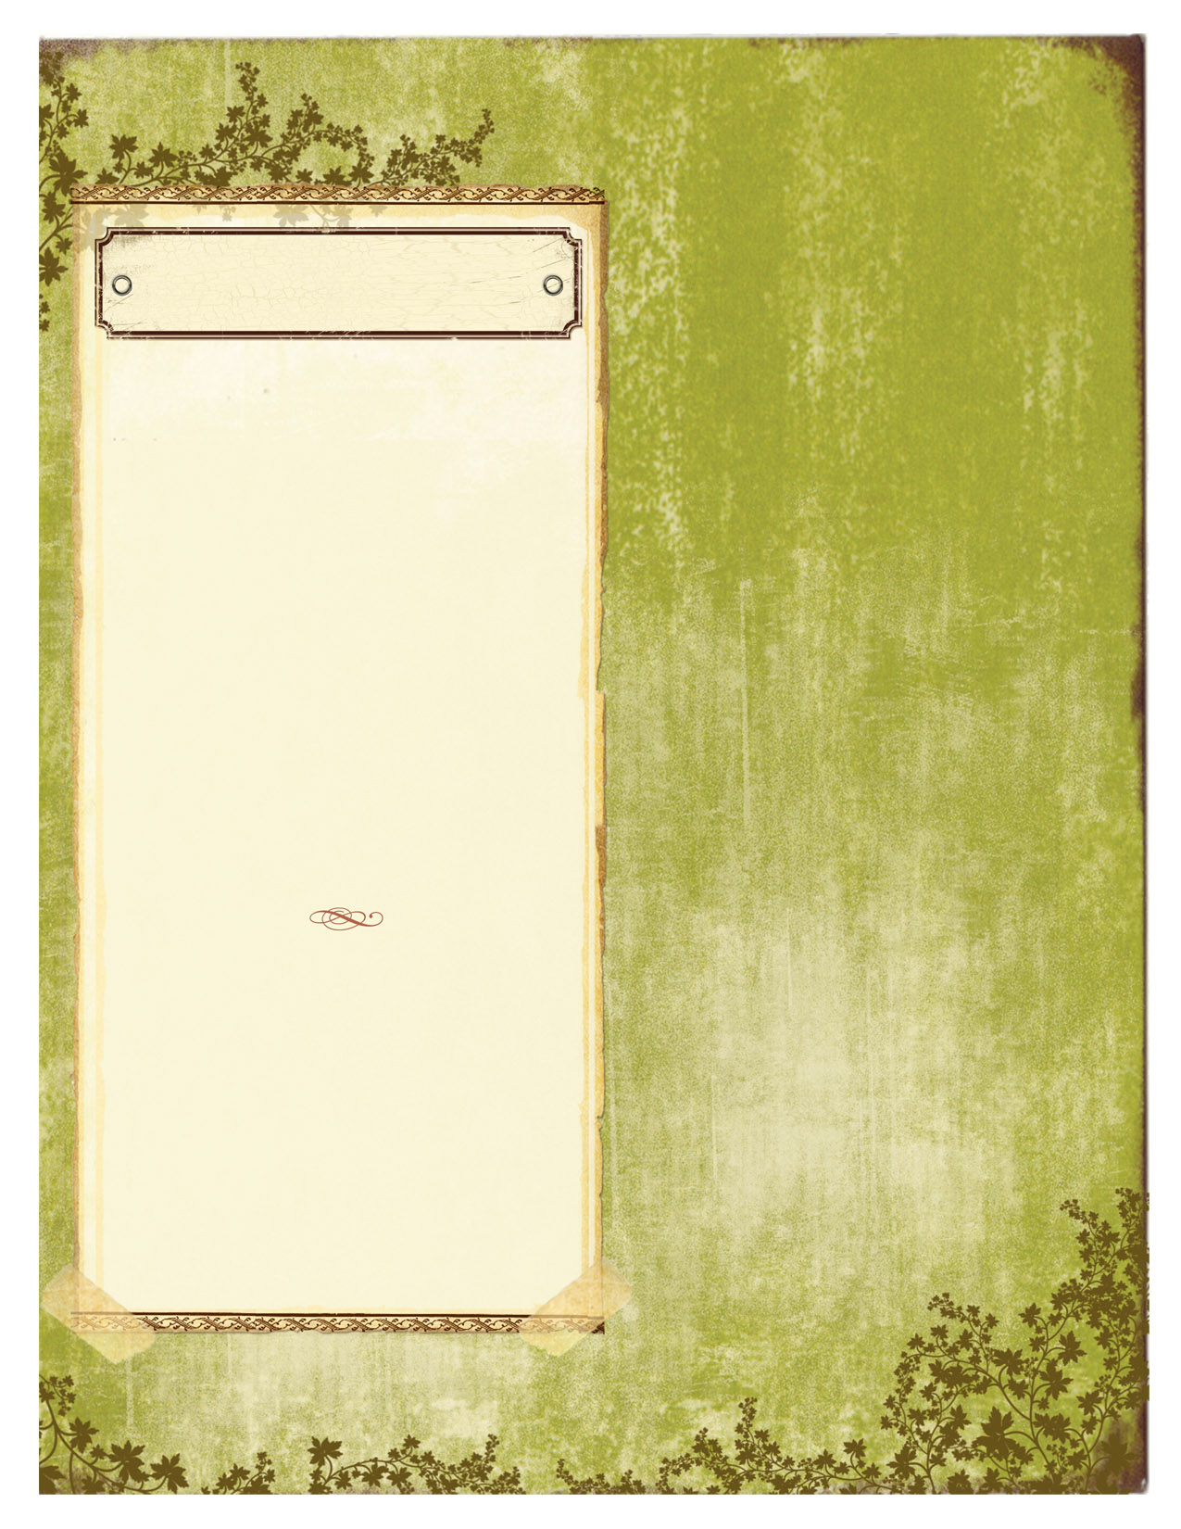

WATERING

METHOD. FREQUENCY.

* **Apply water slowly** to allow it to soak into the soil.
* **Wet the soil to a depth of 12 inches**. This encourages a uniform root system which is better able to withstand future stress.
* **Quick summer showers** may not supply enough moisture to wet the entire area around the root ball.
* **A soil that can be formed into a ball in your hand has sufficient moisture**; loose, dry soil that crumbles in your hand indicates the need for additional watering.
* **Do not over water**, since over watering can leach nutrients from the soil or deplete oxygen availability to the roots.
* **Give special attention** to plants set close to a wall where an overhanging roof may block rainfall.
* **Do not plant high moisture sensitive plants next to gutter downspouts** or other areas where excessively wet soils may develop.
* **If any wilt is evident** or if the foliage feels warm to the touch, WATER! Foliage that is evaporating moisture feels cool to the touch.
* **At least an hour after you water**, probe the soil to see how deeply the water penetrated. If it didn’t reach the rootzone, you may need to increase your watering.
* **Shallow rooted plants** such as rhododendrons, azaleas, and bedding plants may need more frequent watering.
* **Mulch plants whenever possible** to reduce supplemental irrigation. Even if a plant is supposed to be "drought tolerant", it still needs to be mulched and irrigated at least throughout the first growing season after it has been transplanted.
* **Water in the morning** so less water is lost to evaporation.
* **Birch, willow and astilbe** will need longer deeper watering- possibly every day.
* **Yellow lower leaves** indicate the plan has recently severely wilted- WATER.
* **If the temperatures get into the mid 80’s or above**, or if drought is evident, watering frequently is imperative.
* **Special note on Hydrangeas**: Hydrangeas can experience ‘heat droop’ during the day. This is normal and a response to extreme heat and/or sunlight. If your Hydrangea is droopy during the day, but perks up at night or in the morning, it is receiving adequate moisture. If it stills looks droopy in the morning, go ahead and water.
* **Mulch will help conserve the moisture** that is present in the soil and keep down weeds from competing for the water.
* **Water both the root ball and surrounding soil**. Roots grow only where there is moisture, and unless both media are moist the roots may never grow out of the original nursery soil. Plants in such a situation may ultimately girdle themselves and die

TIPS

HOW. WHAT. WHEN.

Watering is the responsibility of the homeowner and no warranty is provided for plants that have not been properly watered. Call at the first sign of distress for advice.

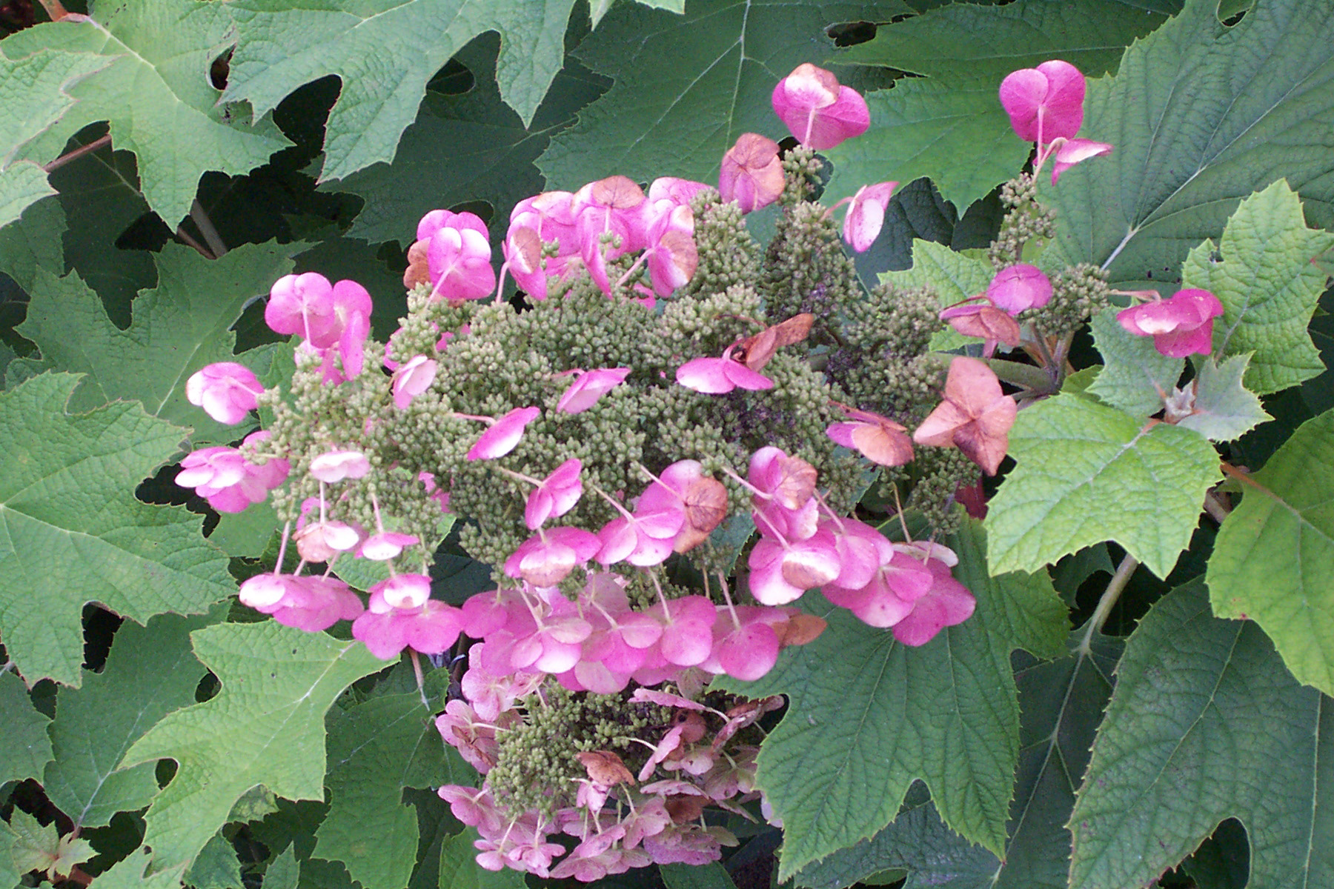

Continue newsletter text here. Continue newsletter text here. Continue newsletter text here. Continue newsletter text here. Continue newsletter text here. Continue newsletter text here. Continue newsletter text here. Continue newsletter text here. Continue newsletter text here. Continue newsletter text here. Continue newsletter text here. Continue newsletter text here. Continue newsletter text here. Continue newsletter text here. Continue newsletter text here. Continue newsletter text here. Continue newsletter text here. Continue newsletter text here Continue newsletter text here

Continue newsletter text here. Continue newsletter text here. Continue newsletter text here. Continue newsletter text here. Continue newsletter text here. Continue newsletter text here. Continue newsletter text here. Continue newsletter text here. Continue newsletter text here.

Continue newsletter text here. Continue newsletter text here. Continue newsletter text here. Continue newsletter text here. Continue newsletter text here. Continue newsletter text here. Continue newsletter text here. Continue newsletter text here. Continue newsletter text here. Continue newsletter text here. Continue newsletter text here. Continue newsletter text here.

Continue newsletter text here. Continue newsletter text here. Continue newsletter text here. Continue newsletter text here. Continue newsletter text here. Continue newsletter text here.

Continue newsletter text here. Continue newsletter text here. Continue newsletter text here. Continue newsletter text here. Continue newsletter text here. Continue newsletter text here. Continue newsletter text here. Continue newsletter text here.

Continue newsletter text here. Continue newsletter text here. Continue newsletter text here. Continue newsletter text here. Continue newsletter text here. Continue newsletter text here. Continue newsletter text here. Continue newsletter text here. Continue newsletter text here.

Proper watering is critical to your plant's health. Regular watering will also help to insure maximum flowering and proper growth. These instructions are just guidelines. No watering schedule is a substitute for observing the condition of your newly planted plants every day. The concept behind this watering schedule is to insure deep root watering for typical soil types and conditions.

Scott’s Landscaping Inc.  
110 Maple Drive  
Centre Hall, PA 16828

Ph 814.364.2100 Fx 814.364.2220

WWW.SCOTTSLANDSCAPINGINC.COM

GUIDELINES

